We look forward to welcoming you to the [INSERT MEET] to be hosted by [INSERT SCHOOL] on [INSERT DATE].

Date INSERT DATE
Location NAME
ADDRESS
CITY
Timeline of Events

TIME | EVENT | LOCATION
8:00 AM | PACKET PICK UP | CHECK-IN TENT
8:15 AM | VOLUNTEER MEETING | CHECK-IN TENT
8:15 AM | COACHES’ MEETING | STARTING LINE
8:45 AM | FIRST RACE REPORT | STARTING LINE
9:00 AM | FIRST RACE | STARTING LINE

Volunteers
Volunteers will meet…

Rosters Entries
- INSERT PALATINE PACK INSTRUCTIONS HERE

Packets
Each team will receive a packet that will be picked up the day of the race at the check-in tent (next to the main parking lot and labeled on the map). The packet will include shoe timing chips with twist ties.

Race Day Meet Communication

Platform: Group Me
- Download App to phone
Group: SPL CROSS COUNTRY 2026
- LINK: CLICK HERE
- QR CODE:
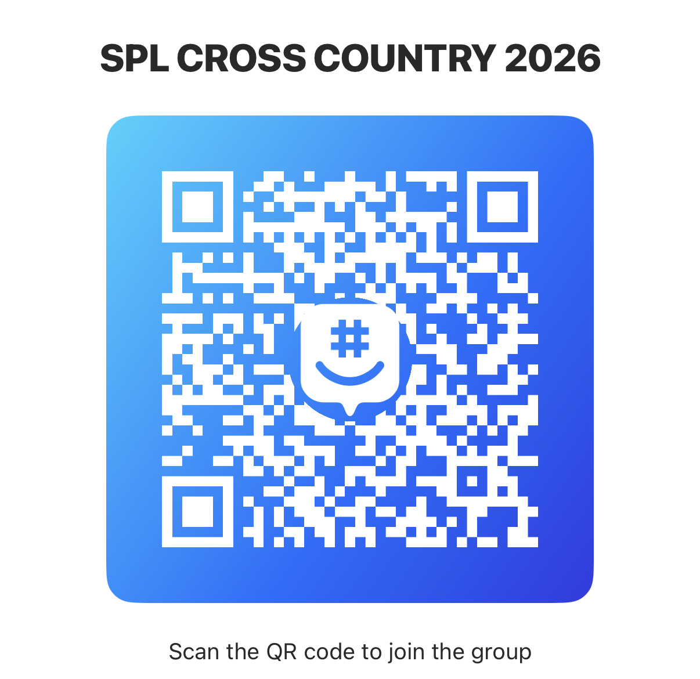

Starting Box
Positions will be set by SPL procedure.

Timing
Timing/scoring will be done by Palatine Pack. We will be using shoe chips for timing. These will need to be returned at the end of the race.

Course
The course is mostly grass with a small portion on a paved path. Runners are responsible for knowing the course. Spikes may be worn.

GRADE | RACE DISTANCE | MAXIMUM TIME
5 | 1.0 | 12 Minutes
6 | 1.5 | 18 Minutes
7-8 | 2.0 | 24 Minutes

Maps
A course map and a parking map are attached. There is a field labeled for over-flow parking on the map.

Facilities
There will be restrooms at the pavilion labeled on the course map.

Tents

Awards

Spectators
Spectators are welcome to watch from any point on the course that is not blocked off with cones or flags.

Concessions
There will be limited concessions on site located next to the check-in tent.

Please let us know if you have any questions.

Thank you,
Meet Director (Meet Director/Athletic Director) PHONE NUMBER
Meet Director (Head Coach) PHONE NUMBER

